A Project report on
ONLINE NOTICE BOARD

Submitted in partial fulfillment for the award of the degree of

BACHELOR OF TECHNOLOGY

in

Computer Science and Engineering

by
P . Bhagya Sri(21A81A05B7)
Md. Mehtab Uzma (21A81A05B1)
K. Anusha(21A81A05A4)
K. Satish(22A85A0509)
U. Phibe(21A81A05C9)

Under the Esteemed Supervision of

Mr. Rama Mohan Rao

Senior Assistant Professor


Department of Computer Science and Engineering

(Accredited by NBA)

SRI VASAVI ENGINEERING COLLEGE (AUTONOMOUS)

(Affiliated to JNTU, Kakinada), pedatadepalli,

Tadepalligudem | 534101, A.P 2023-2024

SRI VASAVI ENG INEERING COLLEGE


DEPARTMENT OF

COMPUTER SCIENCE AND ENGINEERING

CERTIFICATE

This is to certify that the Project Report entitled that “Online Notice Board” is submitted by P . BhagyaSri(21A81A05B7) Md.MehtabUzma(21A81A05B1)
K.Anusha(21A81A05A4) K. Satish(22A85A0509) U. Phibe(21A81A05C9) under the guidance and supervision in partial fulfillment of the requirements for the award of the degree of Bachelor of Technology in Computer Science and Engineering Department of Sri Vasavi Engineering College (Autonomous) during 2020-2021

Project Guide | Head of the Department
Mr. Rama Mohan Rao | Dr. D. Jaya Kumari,
M.Tech,(Ph.D) | M.Tech, Ph. D
Senior Assistant Professor | Professor & HOD

EXTERNAL EXAMINER

DECLARATION BY THE STUDENTS

We hereby declare that the project report entitled “Online Notice Board” submitted by us to Sri Vasavi Engineering College(Autonomous), Tadepalligudem affiliated to JNTU Kakinada in partial fulfillment of the requirement for the award of the B.Tech Degree in Computer Science and Engineering is a record of bonafide project work carried out by us under the guidance of Mr. Rama Mohan Rao Senior Assistant Professor, we further declare that the work reported in this project has not been submitted and will not be submitted either in part or in full, for the award of any other degree in this institute or any other institute on University.

PROJECT ASSOCIATES

P . Bhagya Sri(21A81A05B7)
Md .Mehtab Uzma (21A81A05B1)
K. Anusha(21A81A05A4)
K. Satish(22A85A0509)
U. Phibe(21A81A05C9)

ACKNOWLEDGEMENT

We wish to take this opportunity to express our deep gratitude to all the people who extended their cooperation in various ways during our project work. This is our pleasure to acknowledge the help to all those individuals.

Our sincere thanks to our guide Mr. Rama Mohan Rao – Senior Assistant professor for timely and kind help, guidance and suggestions and ideas during the development of the project.

It’s with a lot of happiness that we are expressing gratitude to Dr. Jayakumari, Head of the Department of Computer Science and Engineering, for timely and kind help, guidance and suggestions throughout the entire project.

Our heartfelt thanks to Dr. G.V.N.S.R RATNAKARA RAO, principal of Sri Vasavi Engineering College, Pedatadepalli, for providing a favorable environment and support in developing this project.

Our Special thanks to management and all the teaching and non-teaching members, Department of Computer Science and Engineering for their support and cooperation during the project report work.

PROJECT ASSOCIATES

P . Bhagya Sri(21A81A05B7)
Md .Mehtab Uzma (21A81A05B1)
K. Anusha(21A81A05A4)
K. Satish(22A85A0509)
U. Phibe (21A81A05C9)

Abstract

In today's colleges, there should be a platform where people can communicate and can exchange information. There should be a centralized platform where students can check information and notices.This project presents the development and implementation of an Online Notice Board system, aimed at changing the way organizations share vital information, announcements, and updates.Using web technologies, the system provides an easy and effective way to share information with a large audience. It uses PHP to handle the database.
TABLE OF CONTENTS

S.NO | TITLE | PAGE NO
Chapter 1 | INTRODUCTION | 11-13
1.1 | Introduction | 12
1.2 | Motivation | 12
1.3 | Objective | 12
1.4 | Scope | 13
1.5 | Project Outline | 13
Chapter 2 | LITERATURE SURVEY | 14-15
Chapter 3 | SYSTEM STUDY AND ANALYSIS | 16-20
3.1 | Problem Statement | 17
3.2 | Existing System | 17
3.3 | Limitations of the Existing System | 17
3.4 | Proposed System | 17
3.5 | Advantages of Proposed System | 17
3.6 | Functional Requirements | 18
3.7 | Non-Functional Requirements | 19
3.8 | Hardware Requirements | 20
3.9 | Software requirements | 20
Chapter 4 | SYSTEM DESIGN | 21-27
4.1 | System Architecture Design | 22
4.2 | UML Diagram | 23-27
Chapter 5 | TECHNOLOGIES | 28-42
5.1 | HTML | 29
5.2 | About HTML | 29

5.3 | Advantages of HTML | 30
5.4 | Disadvantages of HTML | 30
5.5 | CSS | 31
5.6 | About CSS | 32
5.7 | Types of CSS | 33-34
5.8 | Advantages of CSS | 35
5.9 | Disadvantages of CSS | 35
5.10 | PHP | 36
5.11 | About PHP | 36-3
5.12 | Advantages of PHP | 38
5.13 | Disadvantages of PHP | 38
5.14 | Javascript | 39
5.15 | About Javascript | 39
5.16 | Advantages Javascript | 40
5.17 | Disadvantages Javascript | 41
5.18 | Applications of Web Development | 42
Chapter 6 | IMPLEMENTATION | 43-48
6.1 | Implementation | 44
6.2 | MVC Model | 44
6.3 | MVC Components | 45-46
6.4 | MVC Flow Diagram | 47
6.5 | Main Components in project | 48
Chapter 7 | TESTING | 49-54
7.1 | Purpose of testing | 50
7.2 | Types of testing | 50-54
Chapter 8 | OUTPUT SCREENSHOTS | 55-62
8.1 | Laptop View | 56-58
8.2 | Mobile View | 59-62
Chapter 9 | CONCLUSION AND FUTURE WORK | 63-65
9.1 | Conclusion | 64
9.2 | Future Enhancement: | 64
9.3 | References | 65

LIST OF FIGURES

Fig.No | TITLE | PAGE NO
4.1 | System Architecture | 22
4.2 | UML Diagrams | 23
6.1 | Implementation | 44
6.3 | MVC Components | 45
6.4 | MVC Flow Diagram | 47
8.1 | HomePage View | 57
8.2 | Students details view | 57
8.3 | Faculty details view | 58
8.4 | Profile view | 59
8.5 | HOD details view | 59
8.6 | Mobile View | 60

Chapter-1

Introduction

  - Introduction:

Online Notice Board is a web application which is engaged in providing up-to-date articles & notices and other information's for all the users or students. Through a web-based interface or dedicated applications, users can access and interact with a centralized hub of announcements, updates, events, and notifications. Faculty will be able to register on this website and they will get special privilages. They can post notice and information and sort this information according to departments. Students can view the information posted by faculty.There will be admin panel to control the faculty account. It will have the options to delete users, delete their posts and add new users etc. PHP is used to create new users, performing CRUD operations, creating admin panel to manipulate registered users etc.
1.2 Motivation:

The motivation behind this project is to address the challenges associated with traditional notice board systems. Physical notice boards often lead to outdated information, difficulties in accessing notices, and environmental waste due to paper-based notices. This online notice board aims to overcome these limitations by providing a dynamic and eco-friendly solution that ensures real-time access to relevant information. The Online Notice Board Project is rooted in the need for a more organized, efficient, and secure means of communication compared to conventional methods. It strives to address the challenges posed by informal communication platforms like WhatsApp and offers a controlled and private environment for sharing information.
1.3 Objective:

The project's primary objectives encompass the development of a comprehensive online notice board with distinct user roles, including students, faculty, and administrators. The aim is to establish effective communication within the educational institution. This involves providing a user-friendly interface for students, faculty, and administrators to efficiently post and access notices. Additionally, there's a focus on promoting the official and structured nature of these notices, ensuring important information is conveyed clearly. To enhance the overall user experience, an interactive platform with features like notifications and user profile management will be developed. Furthermore, administrators will be empowered to systematically manage notices and faculty registrations across various categories. Lastly, stringent data security measures will be put in place to safeguard user information and ensure privacy in communications.

3

1.4 Scope:

The scope of the Online Notice Board Project includes the development of a digital platform for efficient communication within an educational institution. It encompasses distinct user modules for students, faculty, and administrators, with each module having specific responsibilities. The project emphasizes user roles, official communication, and data privacy, striving to create a secure, structured, and efficient platform for posting, accessing, and managing notices.

1.5 Project Outline

Chapter 1 | Introduction
Chapter 2 | Literature Survey
Chapter 3 | System study and Analysis
Chapter 4 | Technologies
Chapter 5 | Methodology
Chapter 6 | Implementation
Chapter 7 | Testing
Chapter 8 | Results
Chapter 9 | Conclusion
Chapter 10 | Future Work
Chapter 11 | References

Chapter-2

Literature Survey

2.1 Literature Survey

Title : Online Notice Board

Online Notice Board application, which automates the process of displaying important information in various organizations. The literature review highlights the benefits of using online notice boards, such as improving communication and being cost-effective, but also identifies challenges such as technical expertise and reliable internet connectivity. The Agile methodology was used for the development process, which ensured the system met stakeholder requirements. Overall, the document provides a comprehensive overview of the application and the use of online notice boards in organizations.

6

Chapter-3

System Study and Analysis

3.1 Problem Statement:

In many educational institutions, workplaces, and community organizations, the traditional physical notice boards have become inefficient and outdated. Posting and updating notices, announcements, events, and important information on physical boards is time-consuming and often results in outdated or lost information. This leads to a lack of effective communication, missed deadlines, and reduced engagement among the members or stakeholders.For this , college organizations are using social media apps like whatsapp , Instagram etc.Opting for a professional approach to engage students is generally more effective than exclusively relying on social media platforms.

3.2 Existing System:

A traditional physical notice board, often simply called a "notice board" or "bulletin board," is a physical display board commonly found in various public spaces, institutions, offices, schools, and community centers. Its primary purpose is to post and display printed announcements, notices, and other information for the benefit of a specific audience.
3.3 Limitations of Existing System:

Information displayed on physical notice boards might become outdated quickly, as it relies on manual updates. There's also no way to notify individuals when new information is posted.These are often limited to a specific physical location,people who are not present at that location, such as remote workers or students off-campus, cannot access the information.Also traditional notice boards do not offer search capabilities, making it difficult for users to find specific information among a large number of notices and hence it consumes more time.
3.4 Proposed System:

The primary aim of the proposed system is to establish a web-based platform known as the "Online Notice Board," which offers a convenient way for students to access notices, information, and announcements posted by the college administration.

3.5 Advantages of Proposed System:

The main advantage of this "Online Notice Board" is that the information can be accessible from anywhere with an internet connection, making it convenient for students, faculty, and staff, including those off-campus or studying remotely.Information can be promptly published and refreshed, guaranteeing that the most up-to-date information is immediately accessible to the target audience.Users can easily search for specific notices or information, saving time and effort compared to manually scanning a physical board.Security measures are in place to permit login access exclusively for authorized users, ensuring the protection of the system

3.6 Functional Requirements:

Functional requirements (FRs) are a specific category of software requirements that describe what a system or software application must do. These requirements serve as a blueprint for software development, guiding the design, implementation, and testing processes.These requirements describe "what" the software should do, and they are typically detailed, specific, and testable.
User Registration and Authentication:
Users must log in to access the notice board: The system provides security features through username, password matching where only authorized user can access the system with different authorization level. Password reset functionality should be for users who forget their passwords.
Notice Posting and Management:
Authorized users (administrators or faculty) can post notices. Notices can include a title, content, date, and optional attachments. Notices can be categorized or tagged for easy organization.Notices should support text formatting, such as bold and italics. Notices can be edited, updated, or removed by authorized users.
Notice Display:
Users can view notices sorted by date, category, or relevance. Pagination or infinite scrolling for browsing through multiple notices. Users can search for specific notices using keywords or filters.
User Notifications:
Users can receive notifications (e.g., email or in-app) for new notices or updates to existing notices.
Access Control:
User roles and permissions management to control who can post, edit, and delete notices.
Different user roles (e.g., administrators, faculty, students) with varying levels of access.
Security Measures:
Password encryption and secure user authentication. Protection against unauthorized access and data breaches.
Performance:
Fast loading times for quick access to notices. Scalability to handle a growing number of notices and use

3.7 Non- Functional Requirements:

Non-functional requirements (NFRs) for an online notice board system specify attributes or qualities that describe how the system should perform or behave, rather than specifying specific features or functions.
Performance:
Response Time: The system should respond to user interactions within a certain timeframe (e.g., pages load in under 2 seconds).
Scalability: The system should be able to handle increased traffic and data without a significant decrease in performance.
Reliability:
Availability: The system should be available 24/7 with minimal downtime for maintenance (e.g., 99.9% uptime).
Fault Tolerance: The system should continue to function even in the presence of hardware or software failures.
Security:
Data Encryption: User data, including login credentials and personal information, should be encrypted to protect against unauthorized access.
Access Control: User roles and permissions should be well-defined to ensure that only authorized individuals can access and modify data.
Data Backup: Regular backups of data should be performed to prevent data loss in case of system failures or data corruption.
Scalability:
Capacity Planning: The system should be designed to accommodate future growth in terms of users and data without requiring major architectural changes.
Usability:
User-Friendly Interface: The user interface should be intuitive and easy to navigate to ensure a positive user experience.
Interoperability:
Integration: The system should be able to integrate with other software or systems, such as authentication services or databases.

3.8 Hardware Requirements:

Processor : Intel core i3 4th generation.
Ram : 2 GB or above
Hard Disk : 40GB or above
Input device : Keyboard and Mouse,Touchscreen.
Output device : Monitor or PC.

3.9 Software Requirements:

Operating system : Windows 10 or Higher versions.
Front End : HTML,CSS,JavaScript(js).
Back End : PHP,MySQL.

Chapter-4

System Design

4.1 System Architecture :

- The system architecture for the Online Notice Board Project can be described as a client-server model, where users, including students, faculty members, and administrators, interact with the system through client devices like web browsers. The client-side is responsible for rendering the user interface, handling user interactions, and sending requests to the server. Users access the web application through their browsers and send requests for actions like logging in, viewing notices, updating profiles, and posting notices.

- The server-side comprises several components: a web server, an application server, and a database server. The web server serves the web application to clients and handles HTTP requests. The application server hosts the core business logic of the system, including user authentication, permission checks, notice management, and user profile updates. It also processes user requests and communicates with the database server to retrieve or modify data as necessary. The database server, utilizing PHP and MySQL, stores and manages data related to users, notices, profiles, and other application-specific information.

- The architecture maintains a role-based access control model, ensuring that each category of user (students, faculty, and administrators) has specific permissions and capabilities within the system. This structure guarantees data integrity, security, and separation of concerns, making the system scalable and maintainable. It allows users to access and interact with the system according to their roles and permissions while safeguarding data and logic on the server side

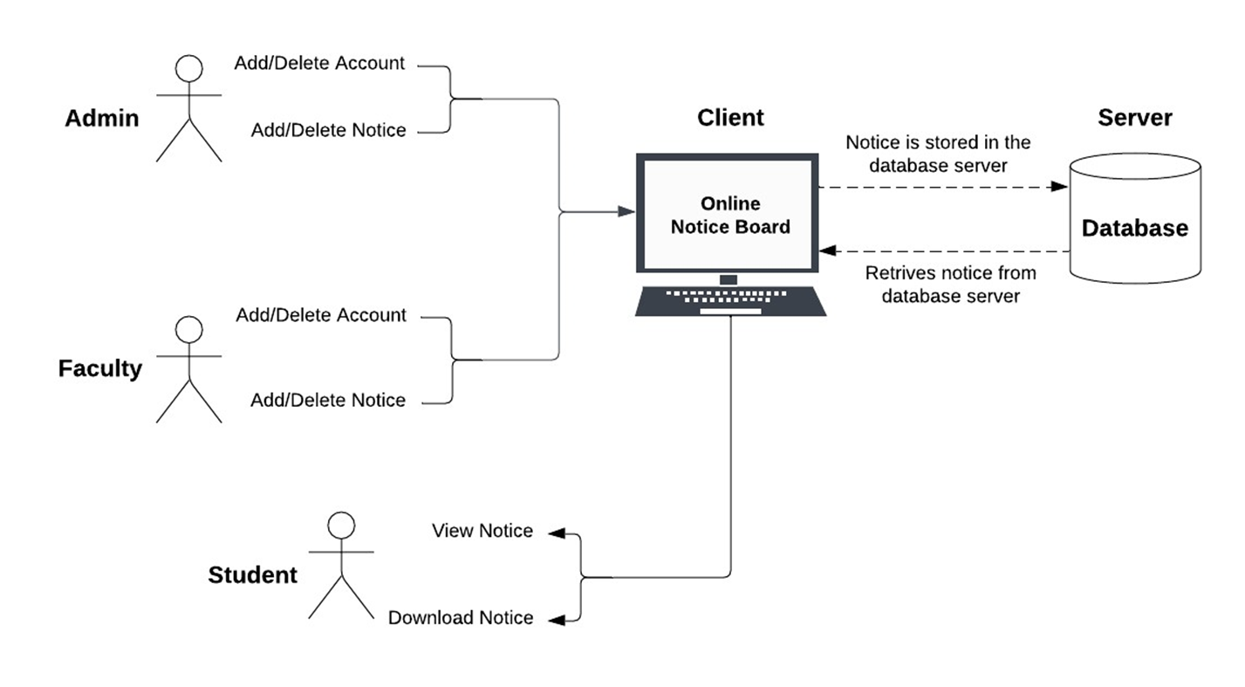

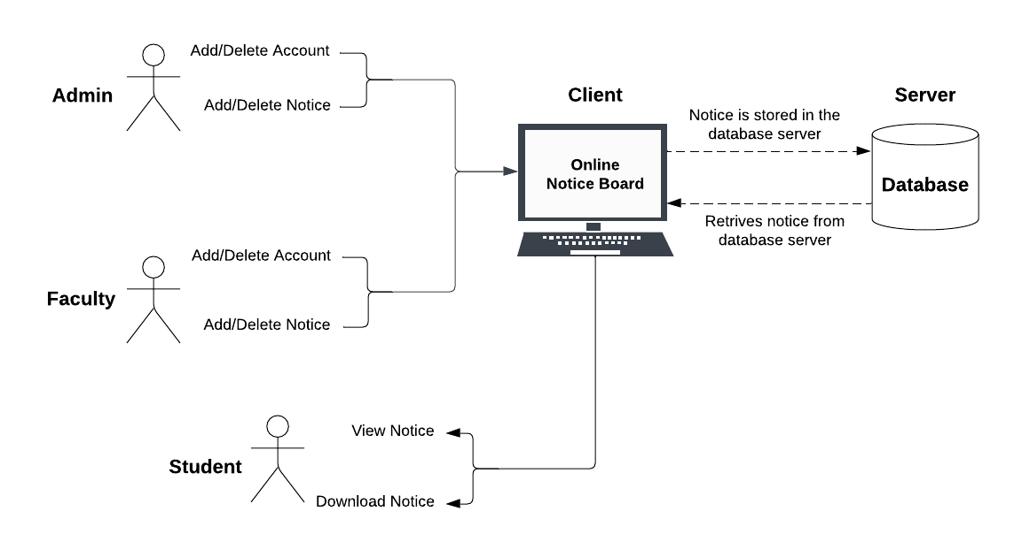

4.2 UML Diagrams:

Use Case Diagram:

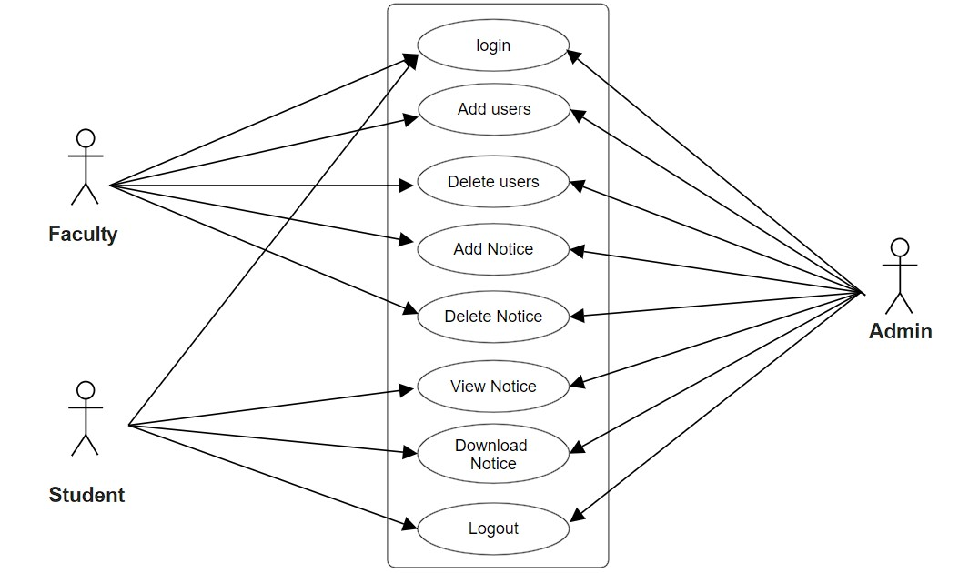

Class Diagram:
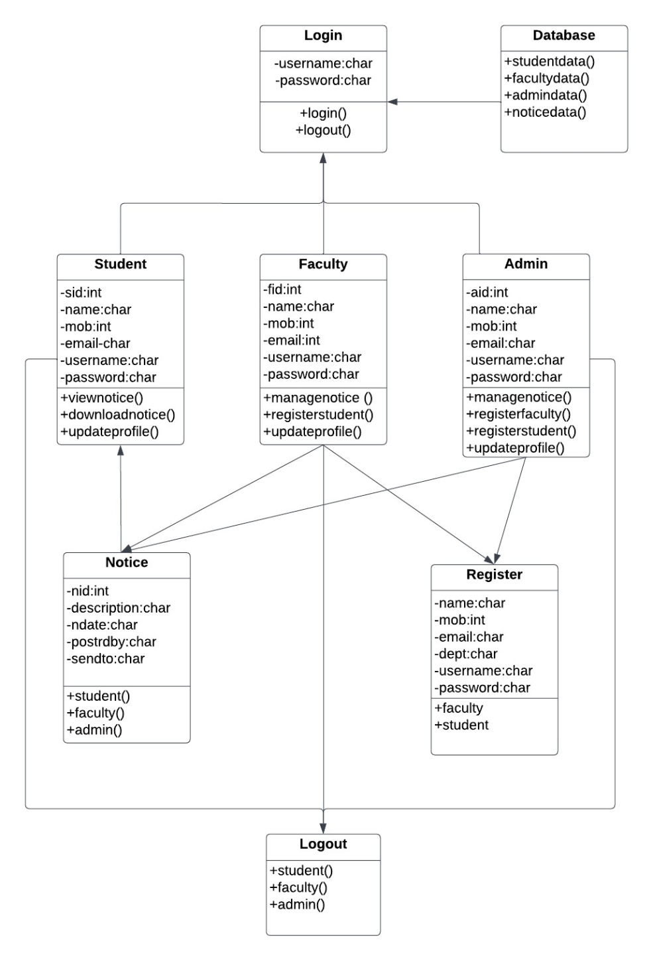

Sequence Diagram:

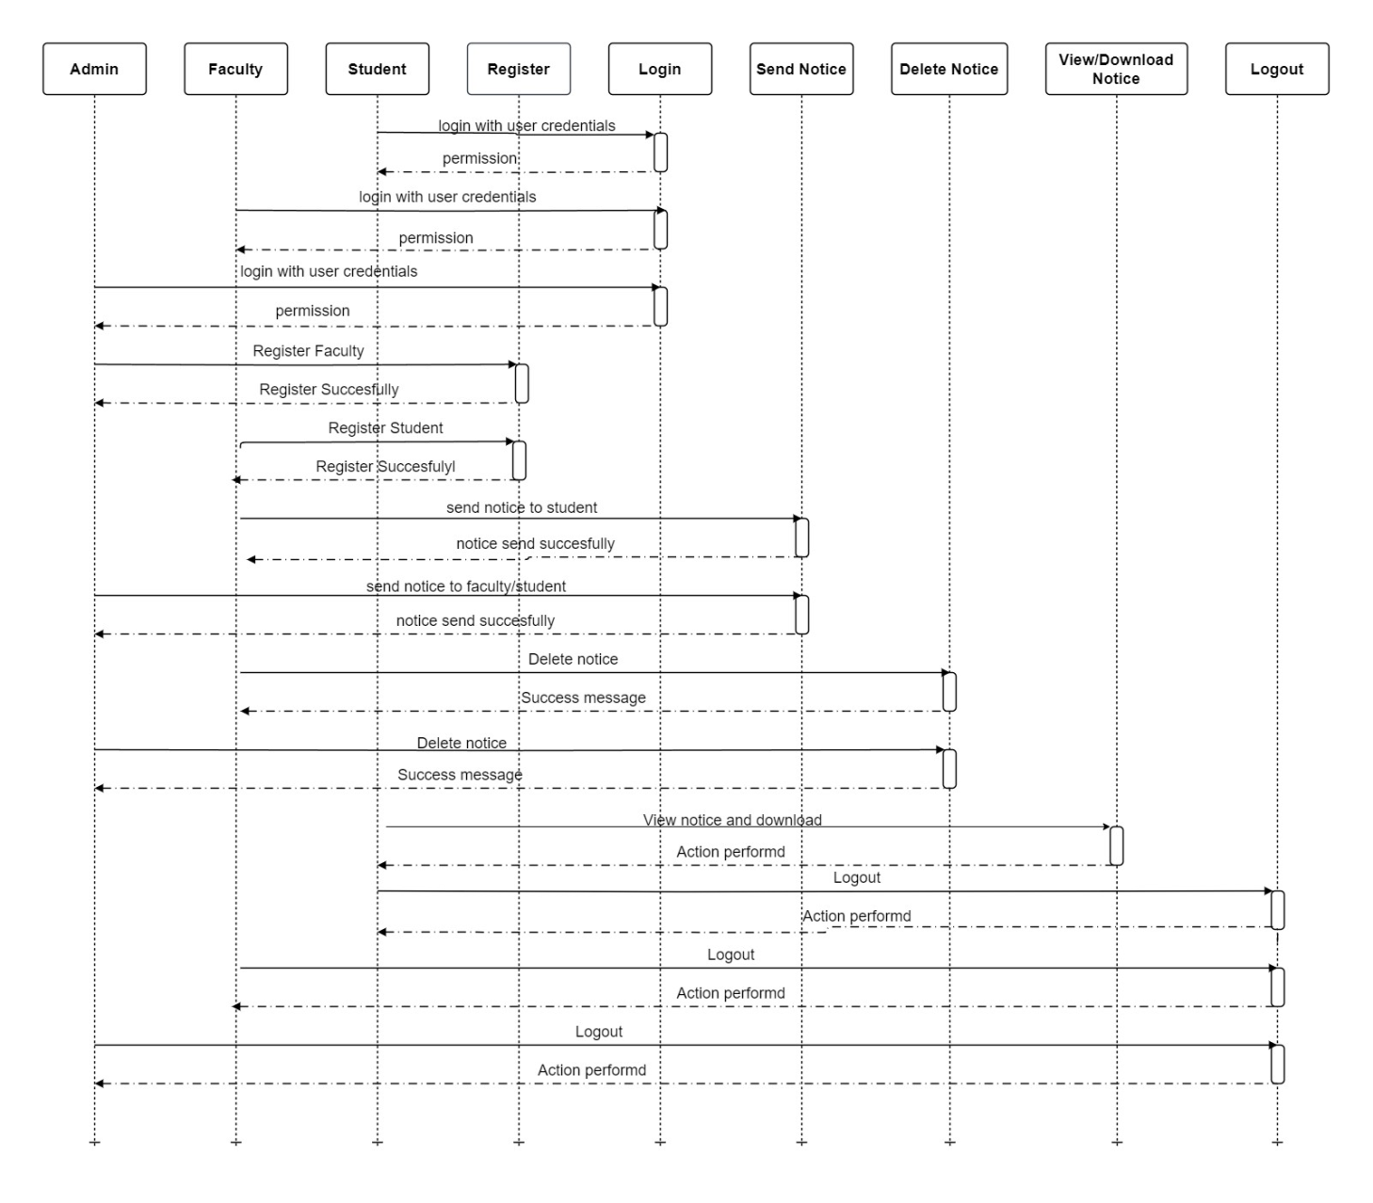

Activity Diagram:

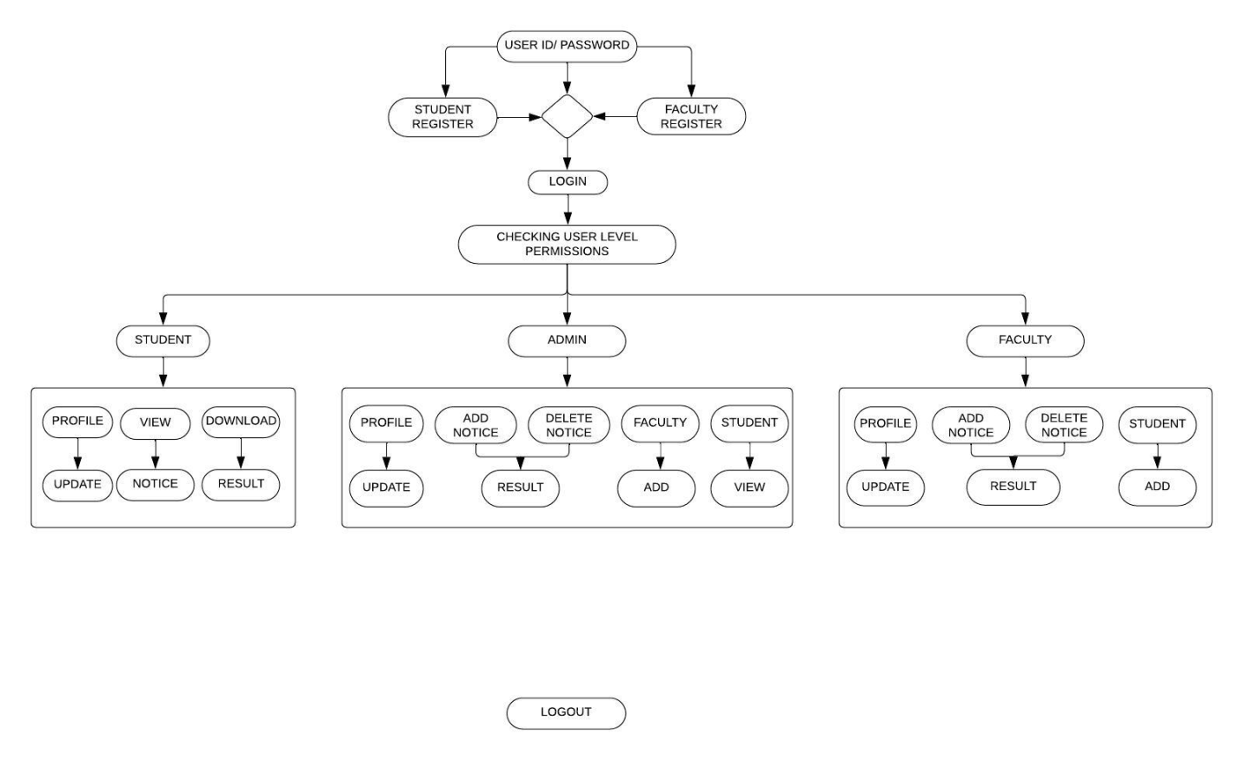

Component Diagram:

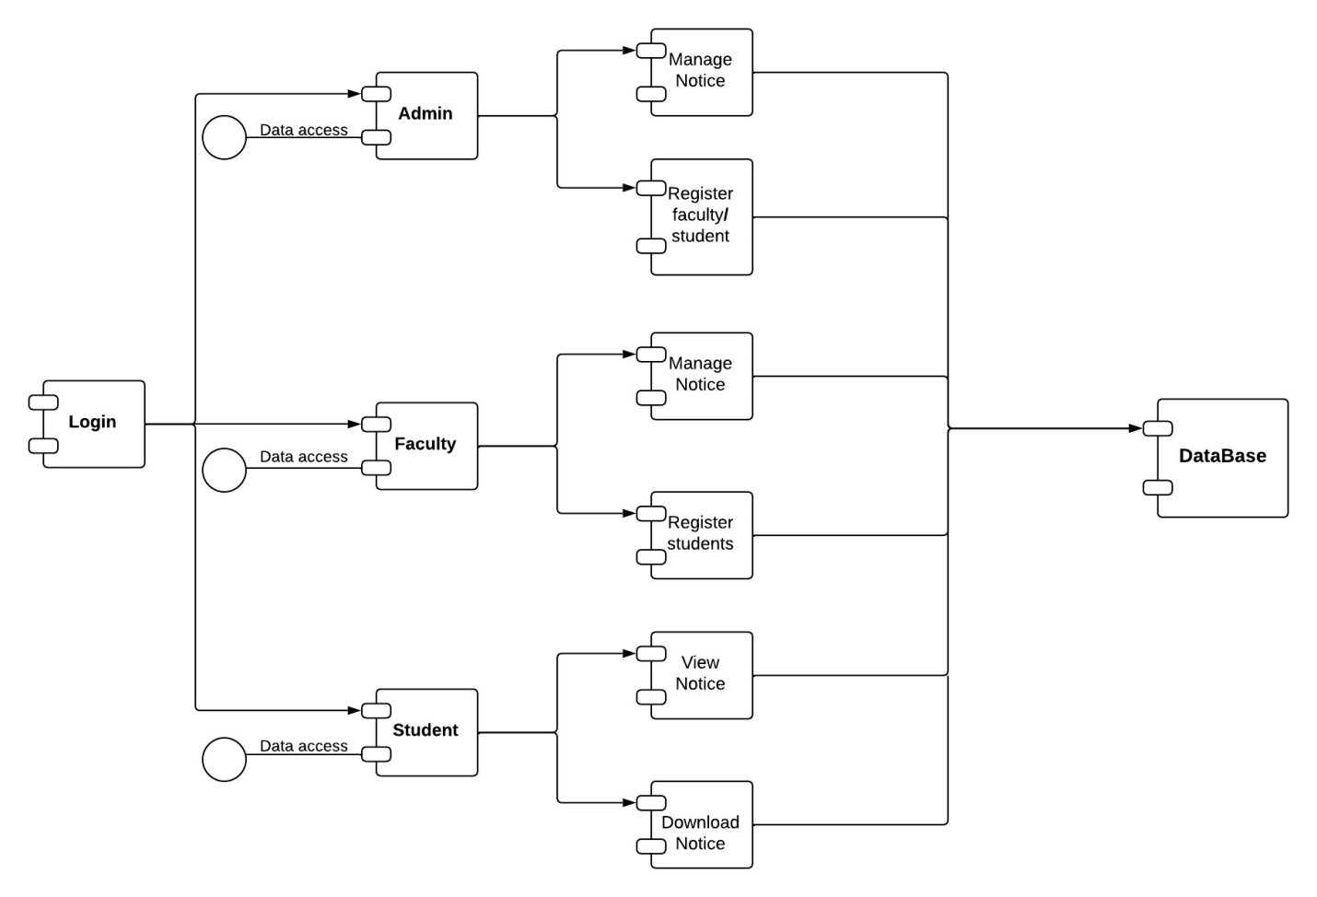

Chapter-5

TECHNOLOGIES

5.1 HTML:

The 1980s saw the birth of hypertext, which is a notion in which papers have links to other documents. Visionaries such as Ted Nelson and Tim Berners-Lee set the groundwork for hypertext in the 1980s. While working at CERN, Tim Berners-Lee presented a system named "Enquire" that can be considered as a forerunner to the World Wide Web.HTML Debuts in the Early 1990s: Tim Berners-Lee developed the first web browser/editor named "WorldWideWeb" and wrote the first online page in 1990. This paved the way for HTML. The initial HTML proposal was made in 1993 as a mechanism to arrange and link documents on the nascent World Wide Web.HTML 1.0 (1993): In 1993, the first official HTML specification was published. It was quite simple and mostly focused on document structuring with headings, lists, and links.HTML 2.0 (1995) added functionality such as forms, text-level formatting (bold, italics), and rudimentary tables.HTML 3.2 (1997): HTML 3.2 added frame support, better tables, and background image support. During this time, web browsers such as Netscape Navigator and Internet Explorer were widespread.XHTML (eXtensible HyperText Markup Language) (2000): XHTML (eXtensible HyperText Markup Language) was introduced as a reformulation of HTML as an application of XML (eXtensible Markup Language). It intended for a more structured, clearer syntax.HTML5 (2014): HTML5 was a significant advancement in the evolution of HTML. It added a slew of new elements, properties, and functionalities. It prioritized multimedia support, enhanced forms, and introduced the canvas drawing element. It also had native audio and video support.HTML Living Standard (Continued): Unlike previous versions, HTML5 is meant to be a "living standard." This implies that it is always growing, with new features and improvements introduced over time without the requirement for a specific HTML6 version. The World Wide Web Consortium (W3C) and the Web Hypertext Application Technology Working Group (WHATWG) administer the HTML Living Standard.

5.2 About HTML:

HTML stands for hyper text markup language.HTML is not a programming language; it is a markup language. It is made up of a collection of elements or tags that are used to organize the material on a web page. These elements, such as <tag>, are enclosed in angle brackets and are typically used in pairs, with an opening tag and a closing tag.The structure of a web document is defined using HTML. It includes headings, paragraphs, lists, links, photos, tables, forms, and other elements. These features aid in the organization and formatting of web page content.
Let’s dive deeper to learn more about HTML.

5.3 Advantages of HTML:

- HTML is widely used.

- Every browser supports HTML Language.

- Easy to learn and use.

- HTML is lightweight and fast to load.

- Do not get to purchase any extra software because it’s by default in every window.

- Easy to use

- Loose syntax (although, being too flexible won’t suit standards).

- HTML is easy enough to write

- HTML is that it is easy to code even for novice programmers.

- HTML also allows the utilization of templates, which makes designing a webpage easy.

- Very useful for beginners in the web designing field.

- HTML can be supported to each and every browser, if not supported to all the browsers.

- HTML is built on almost every website, if not all websites.

- HTML is increasingly used for data storage like XML syntax.

- Free – You need not buy any software.

- HTML is present in every window by default so you do not need to buy the software which costs too much.

- HTML has many tags and attributes which can shorten your line of code.

5.4 Disadvantages of HTML:

- It cannot produce dynamic output alone, since it’s a static language.

- Making the structure of HTML documents becomes tough to understand.

- Errors can be costly.

- It is as time consuming as the time it consumes to maintain the colour scheme of a page and to make lists, tables and forms.

- It can create only static and plain pages so if we’d like dynamic pages then HTML isn’t useful.

- Required to write a lot of code for just creating a simple webpage.

- We have to check up the deprecated tags and confirm not to use them to appear because another language that works with HTML has replaced the first work of the tag, and hence the opposite language needs to be understood and learned.

- Security features offered by HTML are limited.

- If we need to write down long code for creating a webpage then it produces some complexity.

- HTML can create only static and plain pages so if we’d like dynamic pages then HTML isn’t useful.

- I need to write down tons of code for creating an easy webpage.

- Security features are not good at HTML.

- If we’d like to write down long code for creating a webpage then it produces some complexity.

5.5 CSS(Cascading Style Sheets):

Cascading Style Sheets (CSS) is a style sheet language used for describing the presentation of a document written in a markup language such as HTML.[1] CSS is a cornerstone technology of the World Wide Web, alongside HTML and JavaScript.[2]
CSS is designed to enable the separation of presentation and content, including layout, colors, and fonts.[3] This separation can improve content accessibility, provide more flexibility and control in the specification of presentation characteristics, enable multiple web pages to share formatting by specifying the relevant CSS in a separate .css file which reduces complexity and repetition in the structural content as well as enabling the .css file to be cached to improve the page load speed between the pages that share the file and its formatting.

Separation of formatting and content also makes it possible to present the same markup page in different styles for different rendering methods, such as on-screen, in print, by voice (via speech-based browser or screen reader), and on Braille-based tactile devices. CSS also has rules for alternate formatting if the content is accessed on a mobile device.[4]

The name cascading comes from the specified priority scheme to determine which style rule applies if more than one rule matches a particular element. This cascading priority scheme is predictable.

The CSS specifications are maintained by the World Wide Web Consortium (W3C). Internet media type (MIME type) text/css is registered for use with CSS by RFC 2318 (March 1998). The W3C operates a free CSS validation service for CSS documents.[5]

In addition to HTML, other markup languages support the use of CSS including XHTML, plain XML, SVG, and XUL.
5.6 About CSS:

CSS, short for Cascading Style Sheets, is a type of style sheet language. A style sheet language is a language that determines how a document should be designed. A document in this aspect means any text file or webpage that is written in a markup language like HTML, SVG, etc. a shot of dev knowledge
RELATED TAGS

html

css

web

CSS, short for Cascading Style Sheets, is a type of style sheet language. A style sheet language is a language that determines how a document should be designed. A document in this aspect means any text file or webpage that is written in a markup language like HTML, SVG, etc.To make any webpage presentable i.e. to add elements such that it appeals to the user, we use CSS. This can range from placing pictures on webpages, font colors, the background style to as little as the spacing between paragraphs! To do this, CSS uses tags.

20
5.7 Types Of CSS:

1. Internal Stylesheet:

This format allows you to declare the styles within the HTML file, in the head tag. The stylesheet is defined within the <style></style> tags. The snippet below shows how to do this.

<html>


<head>

<!-- This style tag will be used to make the font h1 red ---> <style>
h1{ color: red;}

</style>

</head>

<body>

<div id="content"/>

<h1>The font h1 is red.</h1>

</body>

</html>

2. External Stylesheet:

This is when an external CSS file is written and attached in the HTML document. This external file is written with a .css extension. The snippet below shows the tag to do this.

<html>


<head>

<!--- The line below attaches an external sheet to the HTML file --->

<!--- The stylesheet is taken under the MIT License--->

<link rel="stylesheet" href="https://github.com/dhg/Skeleton/blob/master/css/normalize.css">

</head>


<body>

<div id="content"/>

<small>Text is now following this style!</small>

</body>

</html>

3. Inline Stylesheet

This method is slightly more cluttered than the other two where you define the style within the tag that you want to format. The code snippet below shows how to do this.

<html>

<head>

</head>

<body>

<!-- The style is imbedded within the tag --->

<h1 style="color: red;">h1 is formatted to be red!</h1>

</body>

</html>

5.8 Advantages Of CSS:

- CSS plays an important role, by using CSS you simply have to specify a repeated style for an element once & use it multiple times because CSS will automatically apply the required styles.

- The main advantage of CSS is that style is applied consistently across a variety of sites. One instruction can control several areas which is advantageous.

- Web designers need to use a few lines of programming for every page improving site speed.

- Cascading not only simplifies website development, but also simplifies the maintenance as a change of one line of code affects the whole web site and maintenance time.

- It is less complex therefore the effort is significantly reduced.

- It helps to form spontaneous and consistent changes.

- CSS changes are device friendly. With people employing a variety of smart devices to access websites over the web, there’s a requirement for responsive web design.

- It has the power for re-positioning. It helps us to determine the changes within the position of web elements who are there on the page.

- These bandwidth savings are substantial figures of insignificant tags that are indistinct from a mess of pages.

- Easy for the user to customize the online page

- It reduces the file transfer size.

5.9 Disadvantages Of CSS:

- CSS, CSS 1 up to CSS3, result in creating confusion among web browsers.

- With CSS, what works with one browser might not always work with another. The web developers need to test for compatibility, running the program across multiple browsers.

- There exists a scarcity of security.

- After making the changes we need to confirm the compatibility if they appear. The similar change affects all the browsers.

- The programming language world is complicated for non-developers and beginners. Different levels of CSS i.e. CSS, CSS 2, CSS 3 are often quite confusing.

- Browser compatibility (some styles sheets are supported and some are not).

- CSS works differently on different browsers. IE and Opera support CSS with different logic.

- There might be cross-browser issues while using CSS.

- There are multiple levels which creates confusion for non-developers and beginners.

5.10 php : -

PHP was conceived sometime in the fall of 1994 by Rasmus Lerdorf. Early non-released versions were used on his home page to keep track of who was looking at his online resume. The first version used by others was available sometime in early 1995 and was known as the Personal Home Page Tools. It consisted of a very simplistic parser engine that only understood a few special macros and a number of utilities that were in common use on home pages back then. A guestbook, a counter and some other stuff. The parser was rewritten in mid-1995 and named PHP/FI Version 2. The FI came from another package Rasmus had written which interpreted html form data. He combined the Personal Home Page tools scripts with the Form Interpreter and added mSQL support and PHP/FI was born. PHP/FI grew at an amazing pace and people started contributing code to it.It is difficult to give any hard statistics, but it is estimated that by late 1996 PHP/FI was in use on at least 15,000 web sites around the world. By mid-1997 this number had grown to over 50,000. Mid-1997 also saw a change in the development of PHP. It changed from being Rasmus' own pet project that a handful of people had contributed to, to being a much more organized team effort. The parser was rewritten from scratch by Zeev Suraski and Andi Gutmans and this new parser formed the basis for PHP Version 3. A lot of the utility code from PHP/FI was ported over to PHP3 and a lot of it was completely rewritten.Today (end-1999) either PHP/FI or PHP3 ships with a number of commercial products such as C2's StrongHold web server and RedHat Linux. A conservative estimate based on an extrapolation from numbers provided by NetCraft (see also Netcraft Web Server Survey) would be that PHP is in use on over 1,000,000 sites around the world. To put that in perspective, that is more sites than run Netscape's flagship Enterprise server on the Internet.Also as of this writing, work is underway on the next generation of PHP, which will utilize the powerful Zend scripting engine to deliver higher performance, and will also support running under webservers other than Apache as a native server module..
5.11 About php:

PHP can actually do anything related to server-side scripting or more popularly known as the backend of a website. For example, PHP can receive data from forms, generate dynamic page content, can work with databases, create sessions, send and receive cookies, send emails, etc. There are also many hash functions available in PHP to encrypt users’ data which makes PHP secure and reliable to be used as a server-side scripting language. So these are some of PHP’s abilities that make it suitable to be used as a server-side scripting language

5.12 Advantages Of php : -

- The most important advantage of PHP is that it’s open-source and free from cost. It can be downloaded anywhere and is readily available
- to use for events or web applications.
- It is platform-independent. PHP-based applications can run on any OS like UNIX, Linux, Windows, etc.
- Applications can easily be loaded which are based on PHP and connected to the database. It’s mainly used due to its faster rate of
- loading over slow internet speed than other programming language.
- It has less learning curve because it is simple and straightforward to use. Someone familiar with C programming can easily work on PHP.
- It is more stable for a few years with the assistance of providing continuous support to various versions.
- It helps in reusing an equivalent code and not got have to write lengthy code and sophisticated structure for events of web applications.
- It helps in managing code easily.
- It has powerful library support to use various function modules for data representation.
- PHP’s built-in database connection modules help in connecting databases easily reducing trouble and time for the development of web applications and content-based sites.
- The popularity of PHP gave rise to various communities of developers, a fraction of which may be potential candidates for hire.
- Flexibility makes PHP ready to effectively combine with many other programming languages in order that the software package could use foremost effective technology for every particular feature.
5.13 Disadvantages Of php :

- It is not that secure due to its open-source, because the ASCII text file is often easily available.
- It is not suitable for giant content-based web applications.
- It has a weak type, which can cause incorrect data and knowledge to users.
- PHP frameworks got to learn to use PHP built-in functionalities to avoid writing additional code.
- Using more features of PHP framework and tools cause poor performance of online applications.
- PHP doesn’t allow change or modification in the core behavior of online applications.
- The PHP frameworks aren’t equivalent in behavior so does their performance and features.
- While PHP may be a powerful tool supported by an outsized community and plentiful reference documentation, there are easier programming
- languages for web apps.
- It is widely believed by the developers that PHP features a poor quality of handling errors. PHP lacks debugging tools, which are needed
- to look for errors and warnings. PHP has less number of debugging tools in comparison to other programming languages.
- It’s highly tough to manage because it’s not competent modular. It already imitates the features of the Java language.
5.14 Javascript:
Brendan Eich first developed JavaScript, a computer language, in about ten days in May 1995. The language, formerly known as Mocha, later modified to LiveScript, and is now known simply as JavaScript, was created to be used on the client-side of websites, enabling the addition of dynamic and interactive components to static HTML texts.JavaScript was initially implemented in Netscape Navigator, which was the most popular browser at the time. The language was quickly adopted by Microsoft for use in Internet Explorer. Due to its simplicity of usage and the fact that it was the only client-side scripting language available at the time, JavaScript quickly gained popularity among web developers.JavaScript gained popularity during the ensuing years and was used to develop a wide range of web applications, such as online games, dynamic menus, and form validation. ECMAScript 4, a new version of the language, was planned in 2002, however, it was ultimately abandoned because of conflicts among the various browser vendors.With an estimated 95% of websites utilizing it in some capacity, JavaScript is currently one of the most popular programming languages in use worldwide. It is employed not only in web development but also in the creation of server-side applications, desktop and mobile applications, and even the programming of robots and other hardware.
5.15 About Javascript:
JavaScript (JS) is the most popular lightweight, interpreted compiled programming language. It can be used for both Client-side as well as Server-side developments. JavaScript also known as a scripting language for web pages.JavaScript is used by many developers (65% of the total development community), and the number is increasing day by day. JavaScript is one such programming language that has more than 1444231 libraries and increasing rapidly. It is preferred over any other programming language by most developers. Also, major tech companies like Microsoft, Uber, Google, Netflix, and Meta use JavaScript in their projects. To learn more reasons, please refer Reasons to Learn JavaScript article.

5.16 Advantages of Javascript:
- Regardless of where you host JavaScript, it always gets executed on the client environment to save lots of bandwidth and make the execution process fast.
- In JavaScript, XML Http Request is an important object that was designed by Microsoft. The object calls made by XML Http Request as an asynchronous HTTP request to the server to transfer the data to both sides without reloading the page
- The biggest advantage of JavaScript having the ability to support all modern browsers and produce an equivalent result.
- Global companies support community development by creating projects that are important. An example is Google (created the Angular framework) or Facebook (created the React.js framework).
- JavaScript is employed everywhere on the web.
- JavaScript plays nicely with other languages and may be utilized in an enormous sort of applications.
- There are many open-source projects that provide useful help for developers to add JavaScript.
- There are many available courses within the field of JavaScript, because of which you’ll quickly and simply expand your knowledge of this programming language.

5.17 Disadvantages Javascript:
- This may be difficult to develop large applications, although you’ll also use the TypeScript overlay.
- This applies to larger front-end projects. The configuration is often a tedious task to the number of tools that require to figure together to make an environment for such a project. This is often directly associated with the library’s operation.
- The main problem or disadvantage in JavaScript is that the code is always visible to everyone anyone can view JavaScript code.
- No matter what proportion fast JavaScript interprets, JavaScript DOM (Document Object Model) is slow and can be a never-fast rendering with HTML.
- If the error occurs in JavaScript, it can stop rendering the whole website. Browsers are extremely tolerant of JavaScript errors.
- JavaScript is usually interpreted differently by different browsers. This makes it somewhat complex to read and write cross-browser code
- Though some HTML editors support debugging, it’s not as efficient as other editors like C/C++ editors. Hence difficult for the developer to detect the matter.

5.18 Applications of Web Development :

Web applications include online forms, shopping carts, word processors, spreadsheets, video and photo editing, file conversion, file scanning, and email programs such as Gmail, Yahoo and AOL. Popular applications include Google Apps and Microsoft 365.

Chapter-6

Methodology

6.1 Implementation:

The project is being carried out using the Web Technologies to provide the services of the user requirements. The following is the block diagram of a web request processing.
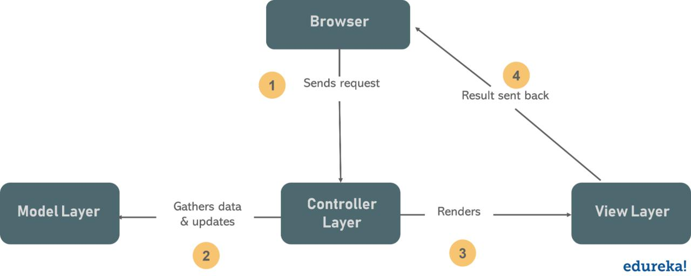

Fig-6.1 Implementation

6.2 MVC MODEL:

The Model-View-Controller (MVC) is an architectural pattern that separates an application into

three main logical components: the model, the view, and the controller. Each of these components

are built to handle specific development aspects of an application. MVC is one of the most

frequently used industry-standard web development frameworks to create scalable and extensible

projects.

6.3 MVC Components

Following are the components of MVC :-
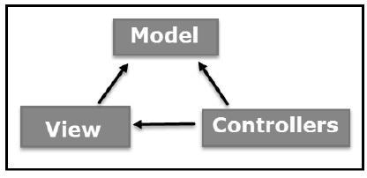

Fig-6.3 MVC Components

Model

The Model component corresponds to all the data-related logic that the user works with. This can represent either the data that is being transferred between the View and Controller components or any other business logic-related data. For example, a Customer object will retrieve the customer information from the database, manipulate it and update its data back to the database or use it to render data.
View

The View component is used for all the UI logic of the application. For example, the Customer view will include all the UI components such as text boxes, dropdowns, etc. that the final user interacts with.

Controller

Controllers act as an interface between Model and View components to process all the business logic and incoming requests, manipulate data using the Model component and interact with the Views to render the final output. For example, the Customer controller will handle all the interactions and inputs from the Customer View and update the database using the Customer Model. The same controller will be used to view the Customer data.

6.4 MVC FLOW DIAGRAM
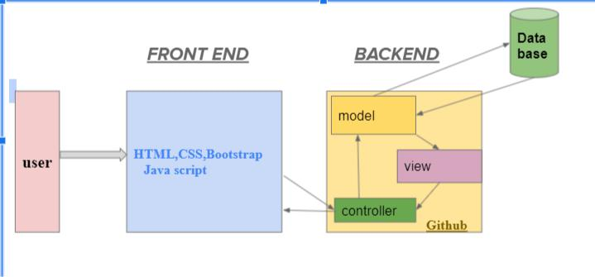

Fig-6.5 MVC Flow Diagram

6.5 Main Components in Project:

Button:
A button is a fundamental UI element that will heavily affect your interaction design. Buttons have the power to compel users to convert, to carry out an action. Buttons are a middleman between the user and the product, and are charged with keeping the conversation between person and machine going.

Cards:
A card is a small rectangular module with images and text. It is an entry point for users to learn more details. To balance the aesthetics and usability of the interface, card UI design is basically a default choice. Because cards are easy to use, they can also display content that contains different elements.

Division:

The div tag is known as Division tag. The div tag is used in HTML to make divisions
of content in the web page like (text, images, header, footer, navigation bar, etc). Div tag
has both open(<div>) and closing (</div>) tag and it is mandatory to close the tag. The
Div is the most usable tag in web development because it helps us to separate out data in
the web page and we can create a particular section for particular data or function in the
web pages.

- Div tag is Block level tag

- It is a generic container tag

- It is used to group various tags of HTML so that sections can be created and style can be applied to them.
CSS Images:

CSS Images is a module of CSS that defines what types of images can be used (the <image> type, containing URLs, gradients and other types of images), how to resize them and how they, and other replaced content, interact with the different layout models.

Chapter-7

Testing

7.1 Purpose of Testing:

Testing in a software project serves multiple crucial purposes. It ensures software quality, detects and fixes bugs before they impact users, validates that the software meets user requirements, verifies the correctness of code implementation, evaluates performance and security, enhances user satisfaction, mitigates development risks, ensures compliance with standards, provides documentation and verification, and supports continuous improvement. Ultimately, testing is essential for reducing defects, improving software quality, and delivering reliable, user-friendly, and secure software solutions.
7.2 Types of Testing:

Unit testing:

Unit testing is a method of testing individual units or components of a software application. It is typically done by developers and is used to ensure that the individual units of the software are working as intended. Unit tests are usually automated and are designed to test specific parts of the code, such as a particular function or method. Unit testing is done at the lowest level of the software development process, where individual units of code are tested in isolation.

Integration testing

Integration testing is a method of testing how different units or components of a software application interact with each other. It is used to identify and resolve any issues that may arise when different units of the software are combined. Integration testing is typically done after unit testing and before functional testing and is used to verify that the different units of the software work together as intended.
Regression Testing :

Regression testing is a method of testing that is used to ensure that changes made to the software do not introduce new bugs or cause existing functionality to break. It is typically done after changes have been made to the code, such as bug fixes or new features, and is used to verify that the software still works as intended.
Regression testing can be performed in different ways, such as:
Retesting:
This involves testing the entire application or specific functionality that was affected by the changes.
Re–execution:
This involves running a previously executed test suite to ensure that the changes did not break any existing functionality.
Comparison:
This involves comparing the current version of the software with a previous version to ensure that the changes did not break any existing functionality.
Functional testing:

Functional tests provide systematic demonstrations that functions tested are available as specified by the business and technical requirements, system documentation and user manuals. Functional testing is centred on the following items:
Valid Input - identified classes of valid input must be accepted. Invalid Input

Functions - identified functions must be exercised. Output - identified classes of

application outputs must be exercised.

Systems/Procedures - interfacing systems or procedures must be invoked.

Organization and preparation of functional tests is focused on requirements, key functions, or special test cases. In addition, systematic coverage pertaining to identifying Business process flows; data fields, predefined processes, and successive processes must be considered for testing. Before functional testing is complete, additional tests are identified and the effective value of current tests is determined.

System Testing:

System testing ensures that the entire integrated software system meets requirements. It tests a configuration to ensure known and predictable results. An example of system testing is the configuration oriented system integration test. System testing is based on process descriptions and flows, emphasizing pre-driven process links and integration points.

White Box Testing:

White Box Testing is a testing in which the software tester has knowledge of the inner workings, structure and language of the software, or at least its purpose. It has a purpose. It is used to test areas that cannot be reached from a black box level.

Black Box Testing:

Black Box Testing is testing the software without any knowledge of the inner workings, structure or language of the module being tested. Black box tests, as most other kinds of tests, must be written from a definitive source document, such as specification or requirements document, such as specification or requirements document. It is a testing in which the software under test is treated, as a black box you cannot see‖ into it. The test provides inputs and responds to outputs without considering how the software works.

Unit Testing:

Unit testing is usually conducted as part of a combined code and unit test phase of the software lifecycle, although it is not uncommon for coding and unit testing to be conducted as two distinct phases.

35

TEST CASES:

1.Student test cases :
Test Case  Description | Test Data | Expected  Result | Actual  Result | Pass/Fail  Criteria
Enter login credentials | login credentials | Homepage page should be displayed | Homepage displayed successfully | Pass
View  Notice | Click on the view notice button | Notice should be displayed | Notice got  displayed | Pass
Download  Notice | Click on download | Successfully  download | Successfully  download | Pass
Logout | Click on logout button | Succesfully exists the page | Succesfully exists the page | Pass

2.Faculty test Cases :

Test Case  Description | Test Data | Expected  Result | Actual  Result | Pass/Fail  Criteria
Enter login credentials | login credentials | Homepage page should be displayed | Homepage was displayed | Pass
Post  Notice | Posting the notice | Notice should be posted | Notice posted successfully | Pass
Add/Delete notice | Adding or deleting a notice | Successfully  added/deleted | Successfully  added/deleted | Pass
Student managing | Register/add/delete student | Successfully  Register/add/delete  students | Successfully  Register/add/delete  students | Pass
Logout | Click on logout button | Succesfully exists the page | Succesfully exists the page | Pass

3.Admin test cases :

Test Case  Description | Test Data | Expected  Result | Actual  Result | Pass/Fail  Criteria
Enter login credentials | login credentials | Homepage page should be displayed | Homepage was displayed | Pass
Post  Notice | Posting the notice | Notice should be posted | Notice posted successfully | Pass
Add/Delete notice | Adding or deleting a notice | Successfully  added/deleted | Successfully  added/deleted | Pass
Faculty  managing | Register/add/delete  Faculty | Successfully  Register/add/delete  Faculty | Successfully  Register/add/delete  Faculty | Pass
View  Student | Click on Button | Student details should be displayed successfully | Students details displayed successfully | Pass
Logout | Click on logout button | Succesfully exists the page | Succesfully exists the page | Pass

Chapter-8

Output Screenshots

Outputs:
8.1 Laptop View:

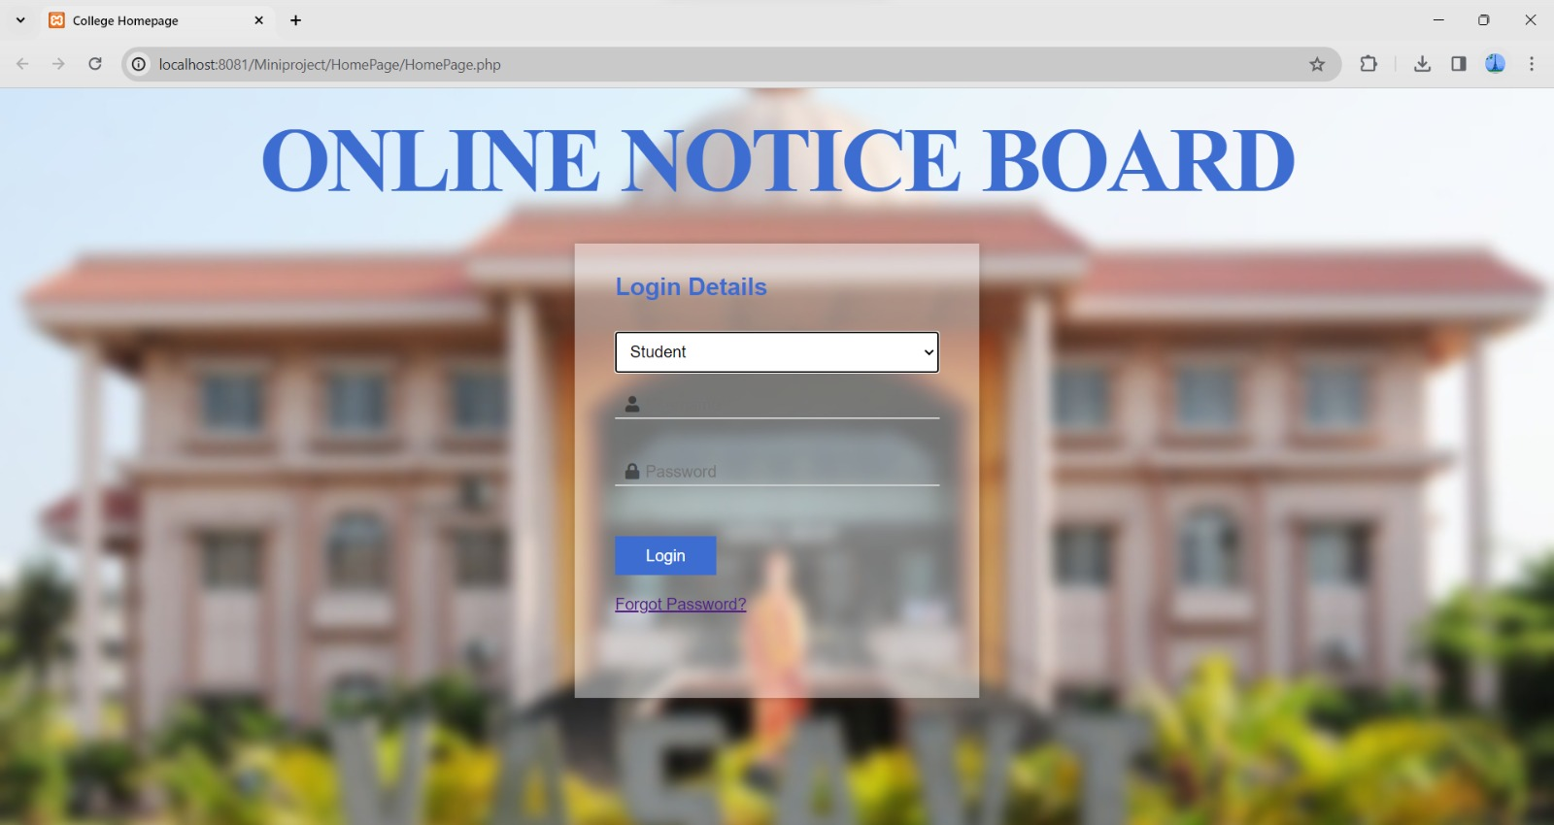

Fig-8.1 Homepage View

8.2 Students details view

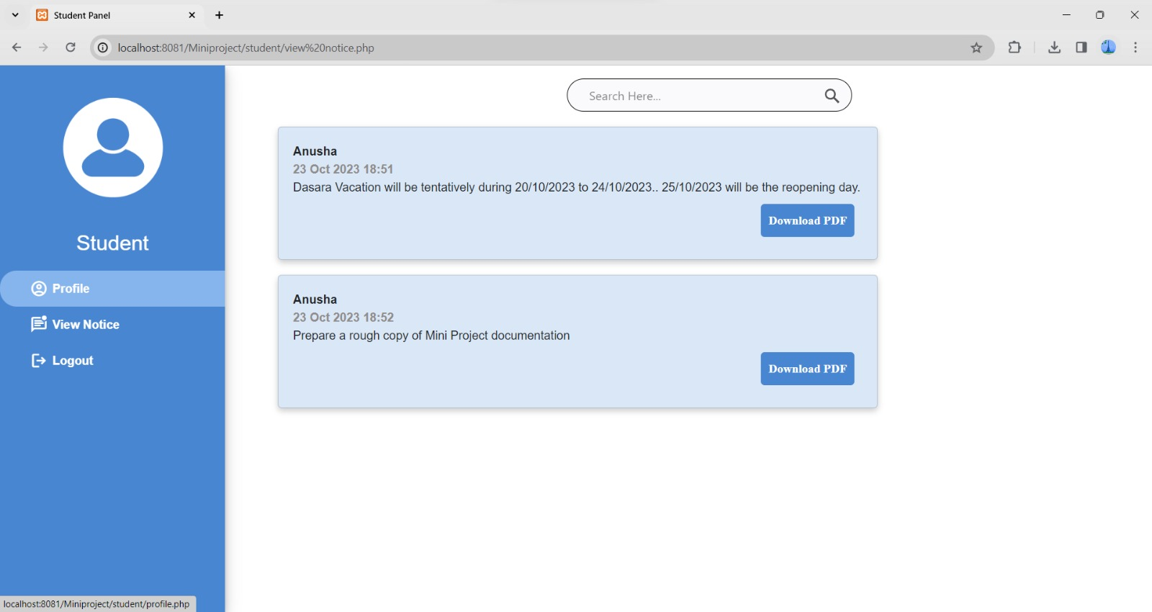
8.21 Student details view:

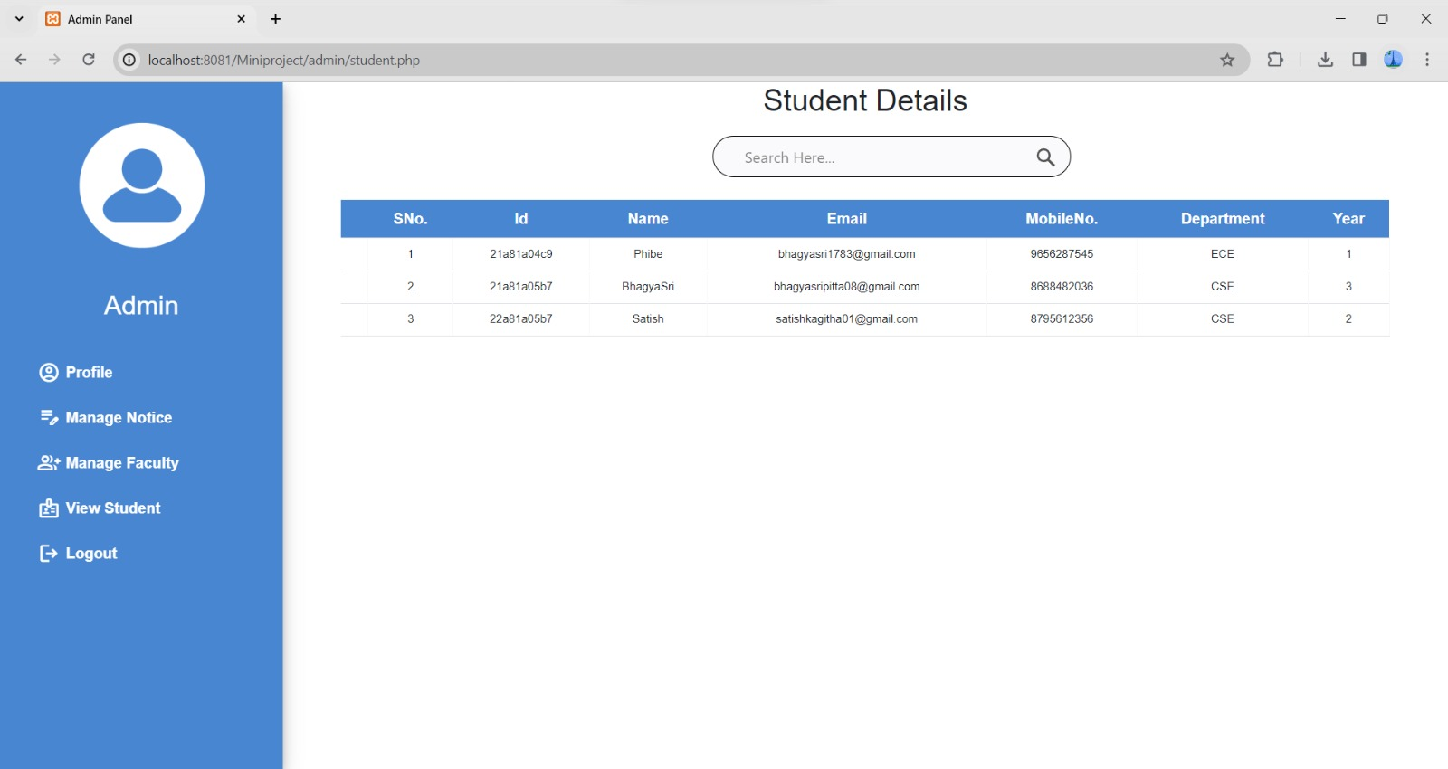

8.3 Faculty details view:

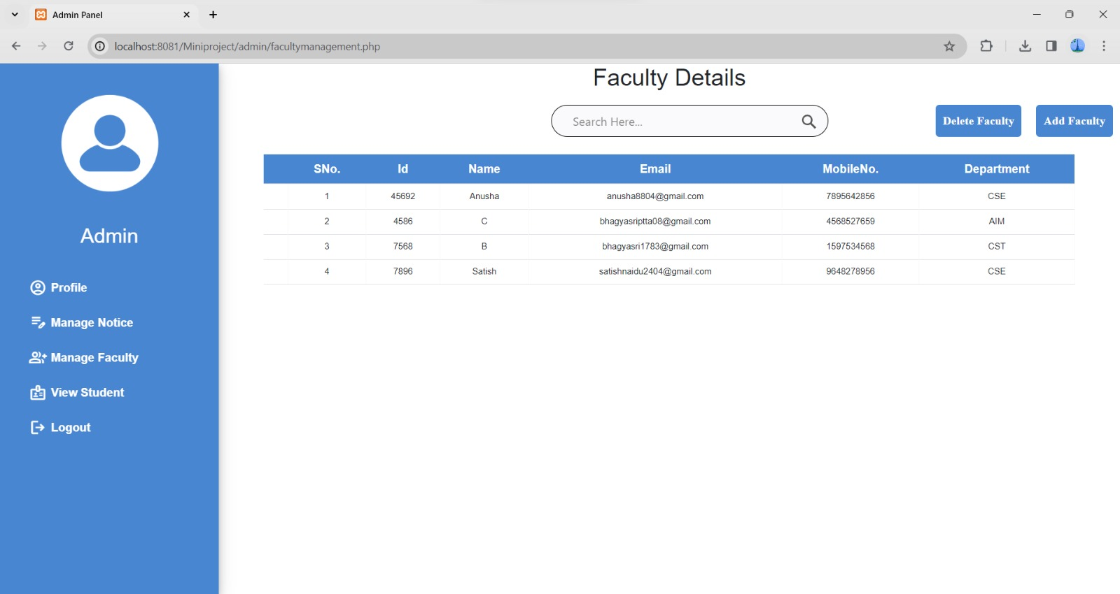

8.4 Profile view:

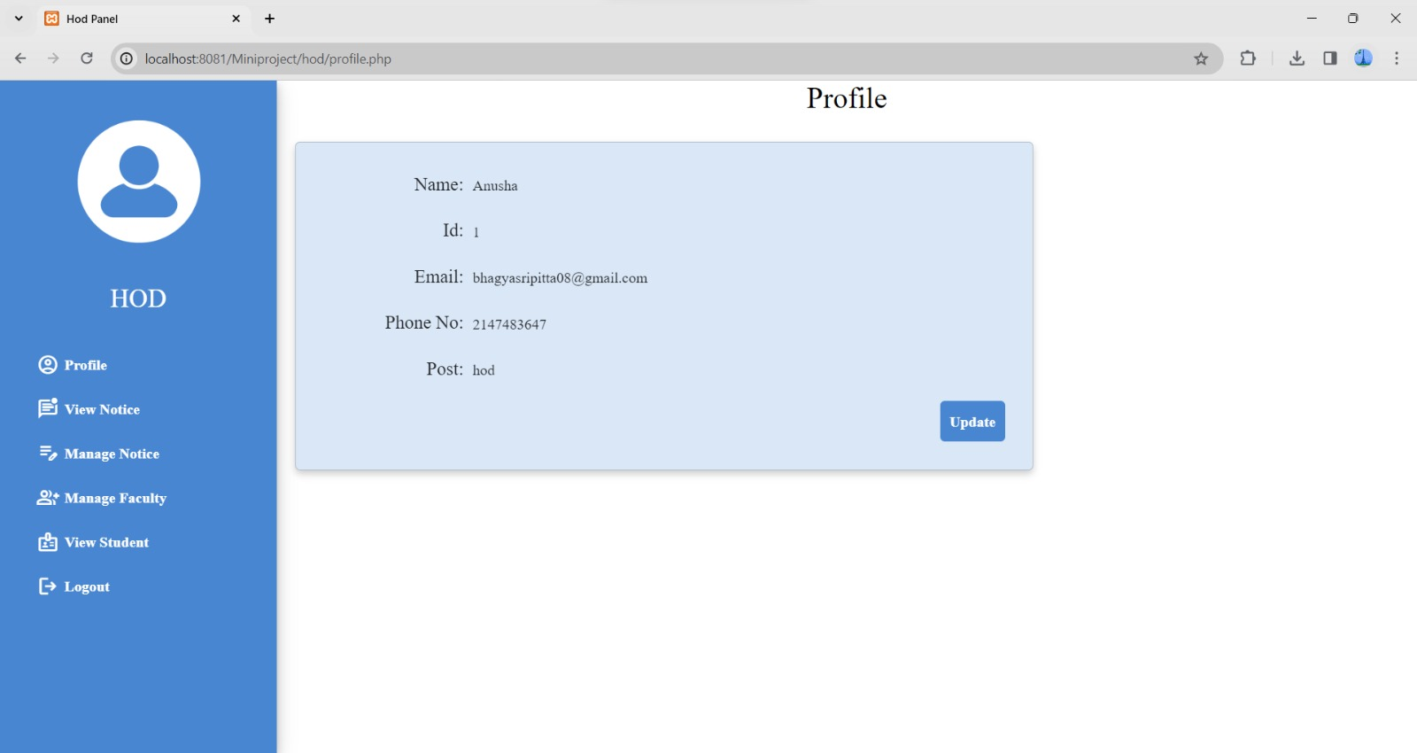

8.5 HOD details view:

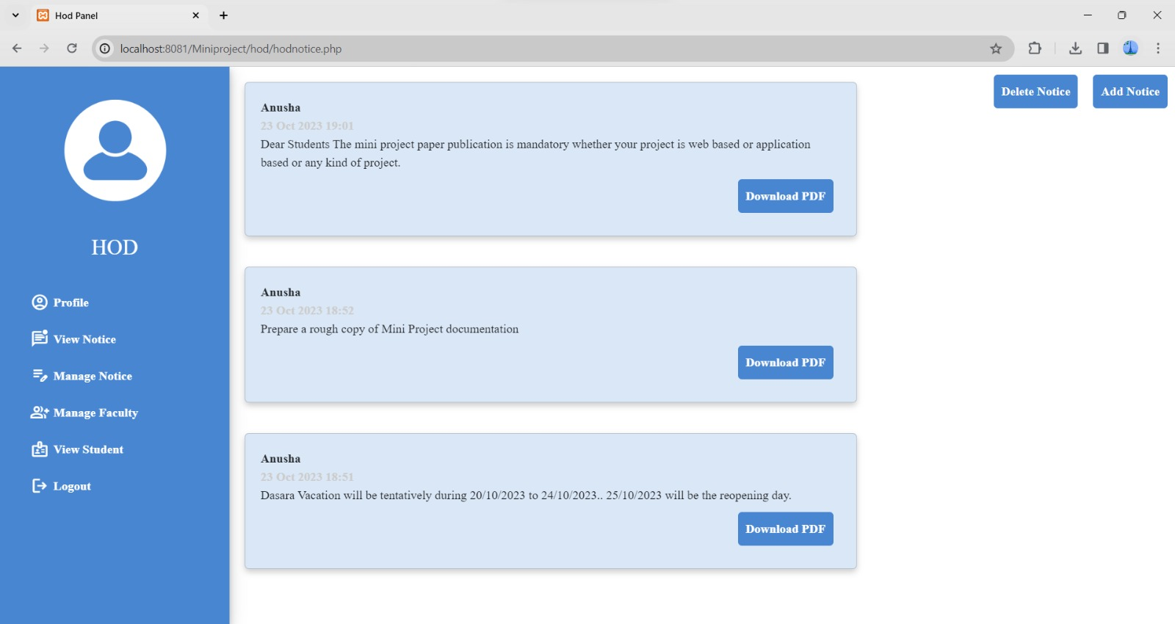

8.6 MOBILE VIEW:

Login view:

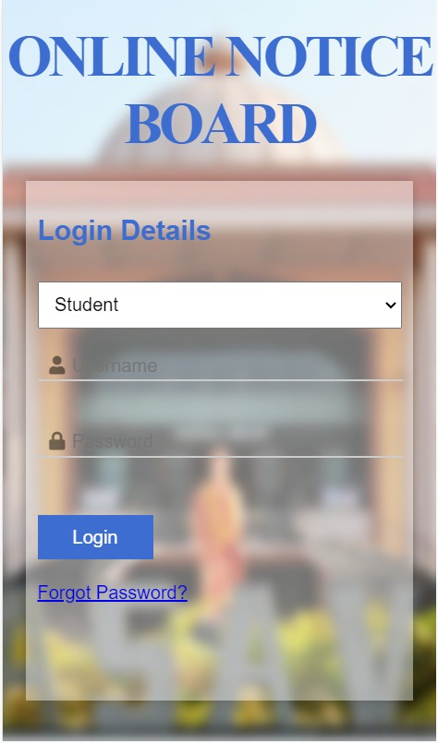

Faculty details view:

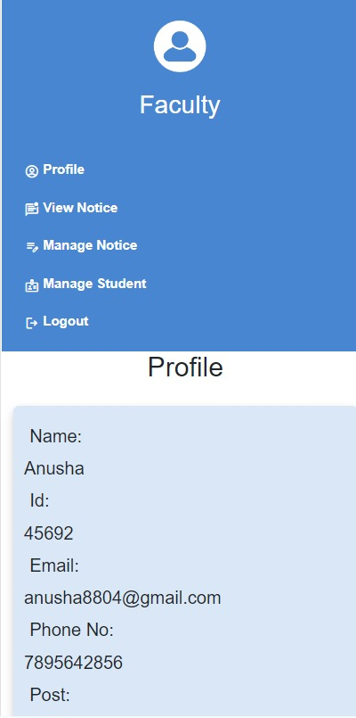

Student details view:

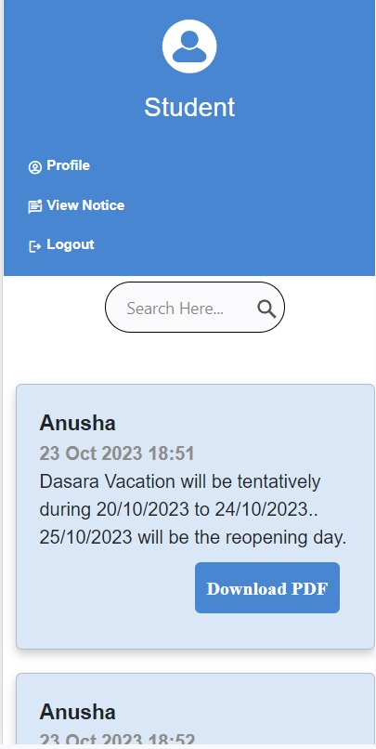

Admin details view:

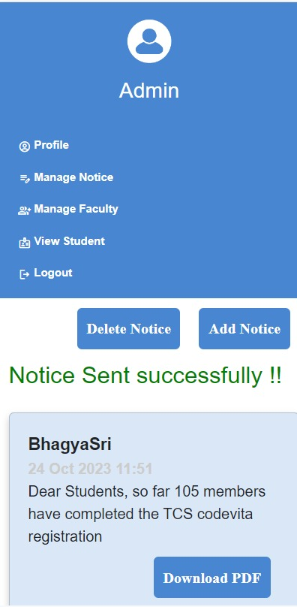

Chapter-9

Conclusion and future work

9.1 Conclusion:

As a final statement , it can be said that a Online Notice Board will have many benefits compared to the old version of sharing information that is a Physical Notice Board . As technology is growing we should need to make improvements in college management. In this system , no need of any physical work it is easy to share the information with students and staff members . In this web application there is a mechanism of posting notice by faculty or admins for delivering information to students and faculty . For Students and faculty it will be easy way for sharing information and to get to know the information . In view of admin they can inform any announcements in short time. Even the literature review have shown that it is a better method for communication . The needs of college organizations have clearly met the methodology used in the development of this web application ,which involves the agile methodology and other phases like first understanding the problem then gathering requirements , planning , system design , implementation , testing and lastly deployment . This idea is a excellent method for college management to communicate in a user-friendly way. The notices can be viewed based on their department and based on their interest like academic notices , examinations notices , general notices and event notices etc . Notice is available at any time to the user . Throughout this we can say that this online notice board system will be a precious platform for providing information and optimizing organizational announcements in a smooth way.

9.2 Future Enhancement:

There are several avenues for potential improvement and expansion of the proposed system to enhance its usefulness and efficiency for educational institutes and organizations . Some prospective directions for development include the popular phase social media into this system in future . The add on of a new column that is alumni panel will be a great idea where they can share their experiences and achievements with students , faculty and all the staff . It would be an amazing betterment of this system for keeping the alumni engaged with the instituition . Besides , if there we give a chance to students as a students panel there it will be an oppurtunity for sharing their ideas and the student co-ordinators , event handling team , any club handling team can also give announcement to all the other students . Additional research can delve into possibilities of this application in different contexts and sectors , aiming to pinpont fresh and enhancements that can be elevate its performance and entire effectiveness .

9.3 References:

[1] Manish Mohan Verma, Manish Singh Papola, Manish Singh Papola,” ONLINE NOTICE BOARD”, International Research Journal of Modernization in Engineering Technology and Science.

[2] Shah Zeb ,Ali Akber ,“Online Notice Board” , KHYBER PAKHTUNKHWA ,PAKISTAN2022 https://ssrn.com/abstract=4359468

[3] Indranil Samanta, Subhasish Raha, Koyena Chattopadhyaya, Garima Chakraborty, Dharmpal Singh,” Web-Based Centralized Notice Board Platform”, EasyChair Preprint.

[4] Menzi Walter Mots, “Implementation of online notice boards as an alternative to location based physical notice boards”, Summer Undergraduate Research Experience (SURE), University Of Cape Town

[5] Sudip Adhikari, Binita Kusum Dhamala,Pratima Chapagai,Prajwal Basnet ,Dharti Raj Shah,Surendra Shresth,” Web-Based Centralized Digital Display Boards Using Local Area Network (LAN) Application”, International Journal of Advanced Engineering.

